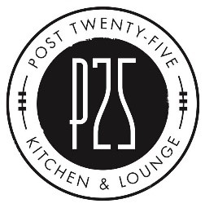
Buffet/Catering Options

Entrees:

Salmon Santorini
Seared salmon fillets over rice, topped with sun dried tomatoes, capers, olives, and a white wine lemon butter sauce.

Mt. Mitchell Meatloaf
Topped with brown gravy and fried onions.
Served with mashed potatoes and green beans.

Chicken Piccata
Lightly breaded chicken breasts served over rice or pasta, topped with lemon, capers, and a white wine butter sauce.

Baked Chicken
Smoked chicken quarters served over rice with seasonal vegetables.

Pulled Pork BBQ
Traditional hickory-smoked pork BBQ, served with Texas toast, baked, beans, mac & cheese, and Cole slaw.

Stations:

Prime Rib Carving Station
A carving station with our wonderfully seasoned prime rib tended by one of our chefs. Served with horseradish sauce, fresh horseradish, au jus, and compound butter.

Pasta Bar
Two noodle types (spaghetti and penne) with our favorite sauces – Greek style Bolognese, vodka sauce, and creamy alfredo. Served with warmed bread and plenty of Parmesan.
Proteins can also be added for an additional fee.

Pizza Station
A selection of house pizzas sliced to feed a crowd. Served with Parmesan and red pepper flakes.
Choose from Peperoni, Cheese, Margherita, or our house favorite, Tiger Flatbreads.

Additional Sides/Options:

Rolls

Garden Salad
Our artisanal lettuce blend with cherry tomatoes, sliced cucumber, red onions, and bell peppers. Served with two dressing choices. Caesar or Greek salads are also available for a slight upcharge.

Seasonal Vegetables
Seasonally available mixed vegetables, roasted to perfection.

Plates/Napkins/Silverware
All the disposable utensils, plates, and serving ware needed to feed your group.
We also have disposable chafing dishes and chafing fuel that can be provided.

Please contact us for a customized quote if choosing multiple options!

